## <http://geekocean.com/introduction-with-json/>

## <http://www.androidhive.info/2012/05/how-to-connect-android-with-php-mysql/>

## ေတြကိုမွီးပါသည္။

## What is JSON?

JSON တိုတာ Javascript Object Notation ကို အတိုေကာက္ေခၚတာပါ။

## Usage

JSON ကို Data ေတြ ပို႔ဖို႔ format တစ္ခု အေနနဲ႔ သံုးပါတယ္။ XML နဲ႔ ဆင္ပါတယ္။ ဒါေပမယ္႔ XML ထက္ ပိုျမန္ပါတယ္။

[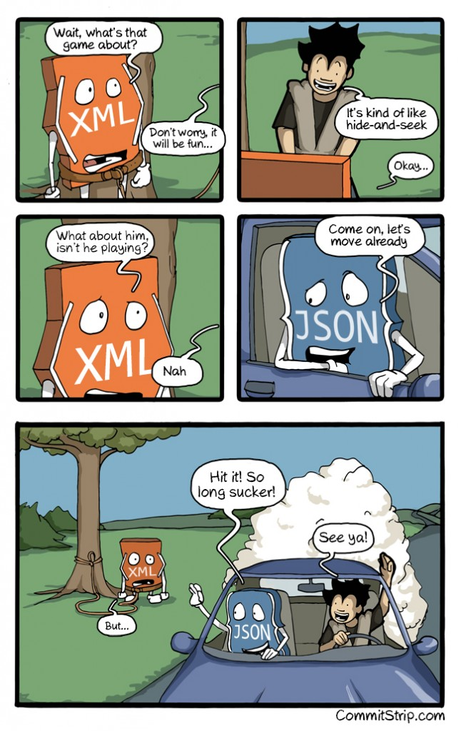](http://geekocean.com/wp-content/uploads/2015/01/Strips-XML-VS-JSON-english.jpg)

## JSON Syntax Example :

JSON အသံုးျပဳထားတဲ႔ Syntax ဟာ Javascript ရဲ႕ အစိတ္အပိုင္း တစ္ခုပဲ ျဖစ္ပါတယ္။ ေအာက္က နမူနာျပထားတဲ႔ TEXT ဆိုတာက JSON Object တစ္ခုပဲ ျဖစ္ပါတယ္။

var TEXT = '{

    "NAME":"JOHN JOHNSON",

    "STREET":"OSLO WEST 16",

    "PHONE":"555 1234567"

}'

JSON မွာ တန္ဖိုးေတြကို "" ႏွစ္ခုၾကားမွာ ထည္႔သြင္းေပးရပါတယ္။ {name:value} ဆိုတဲ႔ format နဲ႔ ေရးရမွာ ျဖစ္ပါတယ္။ ဥပမာ-

Example :

{ “firstName” : “John”,

“lastName” : “Smith” }

Values ေတြ အေနနဲ႔ကေတာ႔ number, string, Boolean, array, object နဲ႔ null တို႔ ျဖစ္ႏိုင္ပါတယ္။ JSON Array ေတြကိုေတာ႔ square bracket [] အတြင္းမွာ ေရးရပါတယ္။

"employees":[

    {"firstName":"John", "lastName":"Doe"},

    {"firstName":"Anna", "lastName":"Smith"},

    {"firstName":"Peter", "lastName":"Jones"}

]

## Usage :

ေအာက္မွာ family ဆိုတဲ႔ JSON array တစ္ခုကို တည္ေဆာက္ျပထားပါတယ္။

    "name" : "Jason",

    "age" : "24",

    "gender" : "male"

},

{

    "name" : "Kyle",

    "age" : "21",

    "gender" : "male"

}];

## Nesting JSON Data

JSON Data ေတြကို nesting ျပဳလုပ္ၿပီးလည္း အသံုးျပဳႏိုင္ပါေသးတယ္။

     {

   "name" : "Jason Lengstorf",

        "age" : "24",

        "gender" : "male"

    },

    "kyle" : {

        "name" : "Kyle Lengstorf",

        "age" : "21",

        "gender" : "male"

    }

}

## Why JSON?

JSON က သံုးရတာ လြယ္တယ္။ ျမန္တယ္။ java နဲ႔ parse လုပ္ၿပီး ကိုယ္လိုခ်င္တဲ႔ အခ်က္အလက္ေတြကို အလြယ္တကူ ျပန္ခြဲထုတ္ႏိုင္တယ္။ ဒါေၾကာင္႔ MySQL db ထဲက အခ်က္အလက္ေတြကို php web services က ရယူၿပီး JSON object အေနနဲ႔ ျပန္ပို႔ေပးပါတယ္။ ဒါကို Android app ကေန ရယူၿပီး ကိုယ္လိုခ်င္တဲ႔ အခ်က္အလက္ေတြကို parse လုပ္ၿပီး အသံုးျပဳတာ ျဖစ္ပါတယ္။

ေအာက္မွာ နမူနာ php code ဖိုင္တစ္ခုျပထားပါတယ္။

**test.php**

|  |
| --- |
| <?php      echo "Welcome, I am connecting Android to PHP, MySQL";  ?> |

**4. Creating MySQL Database and Tables**

MySQL ထဲမွာ နမူနာ database တစ္ခု ေဆာက္ပါ။

|  |
| --- |
| CREATE DATABASE androidhive; |
| CREATE TABLE products(  pid int(11) primary key auto_increment,  name varchar(100) not null,  price decimal(10,2) not null,  description text,  created_at timestamp default now(),  updated_at timestamp  ); |

**5. Connecting to MySQL database using PHP**

**db_config.php** နဲ႔ **db_connect.php ဖိုင္ႏွစ္ခု ဖန္တီးေပးရပါမယ္။**

**db_config.php** – ထဲမွာ database connection variables ေတြ ထည္႔သြင္းေပးရမွာ ျဖစ္ၿပီး  
**db_connect.php** – database ကို ခ်ိတ္ဆက္မယ္႔ class တစ္ခုကို ေရးသားရမွာ ျဖစ္ပါတယ္။ ေအာက္မွာ နမူနာ ျပထားပါတယ္။

**db_config.php**

|  |
| --- |
| db_config.php |
| <?php    /*   * All database connection variables   */    define('DB_USER', "root"); // db user  define('DB_PASSWORD', ""); // db password (mention your db password here)  define('DB_DATABASE', "androidhive"); // database name  define('DB_SERVER', "localhost"); // db server  ?> |

**db_connect.php**

|  |
| --- |
| db_connect.php |
| <?php    /**   * A class file to connect to database   */  class DB_CONNECT {        // constructor      function __construct() {          // connecting to database          $this->connect();      }        // destructor      function __destruct() {          // closing db connection          $this->close();      }        /**       * Function to connect with database       */      function connect() {          // import database connection variables          require_once __DIR__ . '/db_config.php';            // Connecting to mysql database          $con = mysql_connect(DB_SERVER, DB_USER, DB_PASSWORD) or die(mysql_error());            // Selecing database          $db = mysql_select_db(DB_DATABASE) or die(mysql_error()) or die(mysql_error());            // returing connection cursor          return $con;      }        /**       * Function to close db connection       */      function close() {          // closing db connection          mysql_close();      }    }    ?> |

db_connect.php class ကိုသံုးၿပီး MySQL db တစ္ခုကို ေအာက္ပါအတိုင္း ခ်ိတ္ဆက္ႏိုင္ပါတယ္။

|  |
| --- |
| $db = new DB_CONNECT(); // creating class object(will open database connection) |

**6. Basic MySQL CRUD Operations using PHP**

ေအာက္မွာေတာ႔ PHP ကိုသံုးၿပီး db ထဲကို ထည္႔တာ၊ ယူတာ၊ ျပင္တာေတြ ကို လုပ္တဲ႔ နမူနာေတြ ေပးထားပါတယ္။ ဆက္ေလ႔လာၾကည္႔ပါ။ JSON response ကို echo လုပ္ေပးတာကို ဂရုျပဳေလ႔လာေစခ်င္ပါတယ္။

**6.a) Creating a row in MySQL (Creating a new product row)**

In your PHP project create a new php file called **create_product.php** and place the following code. This file is mainly for creating a new product in products table.

In the following code i am reading product data via POST and storing them in products table. At the end i am echoing appropriate JSON as response.

|  |
| --- |
| create_product.php |
| <?php    /*   * Following code will create a new product row   * All product details are read from HTTP Post Request   */    // array for JSON response  $response = array();    // check for required fields  if (isset($_POST['name']) && isset($_POST['price']) && isset($_POST['description'])) {        $name = $_POST['name'];      $price = $_POST['price'];      $description = $_POST['description'];        // include db connect class      require_once __DIR__ . '/db_connect.php';        // connecting to db      $db = new DB_CONNECT();        // mysql inserting a new row      $result = mysql_query("INSERT INTO products(name, price, description) VALUES('$name', '$price', '$description')");        // check if row inserted or not      if ($result) {          // successfully inserted into database          $response["success"] = 1;          $response["message"] = "Product successfully created.";            // echoing JSON response          echo json_encode($response);      } else {          // failed to insert row          $response["success"] = 0;          $response["message"] = "Oops! An error occurred.";            // echoing JSON response          echo json_encode($response);      }  } else {      // required field is missing      $response["success"] = 0;      $response["message"] = "Required field(s) is missing";        // echoing JSON response      echo json_encode($response);  }  ?> |

For the above code JSON response will be like

When POST param(s) is missing

|  |
| --- |
| {      "success": 0,      "message": "Required field(s) is missing"  } |

When product is successfully created

|  |
| --- |
| {      "success": 1,      "message": "Product successfully created."  } |

When error occurred while inserting data

|  |
| --- |
| {      "success": 0,      "message": "Oops! An error occurred."  } |

**6.b) Reading a Row from MySQL (Reading product details)**

Create a new php file called get_product_details.php and write the following code. This file will get single product details by taking product id (pid) as post parameter.

|  |
| --- |
| get_product_details.php |
| <?php    /*   * Following code will get single product details   * A product is identified by product id (pid)   */    // array for JSON response  $response = array();    // include db connect class  require_once __DIR__ . '/db_connect.php';    // connecting to db  $db = new DB_CONNECT();    // check for post data  if (isset($_GET["pid"])) {      $pid = $_GET['pid'];        // get a product from products table      $result = mysql_query("SELECT *FROM products WHERE pid = $pid");        if (!empty($result)) {          // check for empty result          if (mysql_num_rows($result) > 0) {                $result = mysql_fetch_array($result);                $product = array();              $product["pid"] = $result["pid"];              $product["name"] = $result["name"];              $product["price"] = $result["price"];              $product["description"] = $result["description"];              $product["created_at"] = $result["created_at"];              $product["updated_at"] = $result["updated_at"];              // success              $response["success"] = 1;                // user node              $response["product"] = array();                array_push($response["product"], $product);                // echoing JSON response              echo json_encode($response);          } else {              // no product found              $response["success"] = 0;              $response["message"] = "No product found";                // echo no users JSON              echo json_encode($response);          }      } else {          // no product found          $response["success"] = 0;          $response["message"] = "No product found";            // echo no users JSON          echo json_encode($response);      }  } else {      // required field is missing      $response["success"] = 0;      $response["message"] = "Required field(s) is missing";        // echoing JSON response      echo json_encode($response);  }  ?> |

The json response for the above file will be

When successfully getting product details

|  |
| --- |
| {      "success": 1,      "product": [          {              "pid": "1",              "name": "iPHone 4S",              "price": "300.00",              "description": "iPhone 4S white",              "created_at": "2012-04-29 01:41:42",              "updated_at": "0000-00-00 00:00:00"          }      ]  } |

When no product found with matched pid

|  |
| --- |
| {      "success": 0,      "message": "No product found"  } |

**6.c) Reading All Rows from MySQL (Reading all products)**

We need a json to list all the products on android device. So create a new php file named**get_all_products.php** and write following code.

|  |
| --- |
| get_all_products.php |
| <?php    /*   * Following code will list all the products   */    // array for JSON response  $response = array();    // include db connect class  require_once __DIR__ . '/db_connect.php';    // connecting to db  $db = new DB_CONNECT();    // get all products from products table  $result = mysql_query("SELECT *FROM products") or die(mysql_error());    // check for empty result  if (mysql_num_rows($result) > 0) {      // looping through all results      // products node      $response["products"] = array();        while ($row = mysql_fetch_array($result)) {          // temp user array          $product = array();          $product["pid"] = $row["pid"];          $product["name"] = $row["name"];          $product["price"] = $row["price"];          $product["created_at"] = $row["created_at"];          $product["updated_at"] = $row["updated_at"];            // push single product into final response array          array_push($response["products"], $product);      }      // success      $response["success"] = 1;        // echoing JSON response      echo json_encode($response);  } else {      // no products found      $response["success"] = 0;      $response["message"] = "No products found";        // echo no users JSON      echo json_encode($response);  }  ?> |

And the JSON response for above code

Listing all Products

|  |
| --- |
| {      "products": [          {              "pid": "1",              "name": "iPhone 4S",              "price": "300.00",              "created_at": "2012-04-29 02:04:02",              "updated_at": "0000-00-00 00:00:00"          },          {              "pid": "2",              "name": "Macbook Pro",              "price": "600.00",              "created_at": "2012-04-29 02:04:51",              "updated_at": "0000-00-00 00:00:00"          },          {              "pid": "3",              "name": "Macbook Air",              "price": "800.00",              "created_at": "2012-04-29 02:05:57",              "updated_at": "0000-00-00 00:00:00"          },          {              "pid": "4",              "name": "OS X Lion",              "price": "100.00",              "created_at": "2012-04-29 02:07:14",              "updated_at": "0000-00-00 00:00:00"          }      ],      "success": 1  } |

When products not found

|  |
| --- |
| {      "success": 0,      "message": "No products found"  } |

**6.d) Updating a Row in MySQL (Updating product details)**

Create a php file named **update_product.php** to update product details. Each product is identified by pid.

|  |
| --- |
| update_product.php |
| <?php    /*   * Following code will update a product information   * A product is identified by product id (pid)   */    // array for JSON response  $response = array();    // check for required fields  if (isset($_POST['pid']) && isset($_POST['name']) && isset($_POST['price']) && isset($_POST['description'])) {        $pid = $_POST['pid'];      $name = $_POST['name'];      $price = $_POST['price'];      $description = $_POST['description'];        // include db connect class      require_once __DIR__ . '/db_connect.php';        // connecting to db      $db = new DB_CONNECT();        // mysql update row with matched pid      $result = mysql_query("UPDATE products SET name = '$name', price = '$price', description = '$description' WHERE pid = $pid");        // check if row inserted or not      if ($result) {          // successfully updated          $response["success"] = 1;          $response["message"] = "Product successfully updated.";            // echoing JSON response          echo json_encode($response);      } else {        }  } else {      // required field is missing      $response["success"] = 0;      $response["message"] = "Required field(s) is missing";        // echoing JSON response      echo json_encode($response);  }  ?> |

The json reponse of above code, when product is updated successfully

|  |
| --- |
| {      "success": 1,      "message": "Product successfully updated."  } |

**6.e) Deleting a Row in MySQL (Deleting a product)**

The last operation is deletion on database. Create a new php file called delete_product.php and paste the following code. The main functionality of this file is to delete a product from database.

|  |
| --- |
| delete_product.php |
| <?php    /*   * Following code will delete a product from table   * A product is identified by product id (pid)   */    // array for JSON response  $response = array();    // check for required fields  if (isset($_POST['pid'])) {      $pid = $_POST['pid'];        // include db connect class      require_once __DIR__ . '/db_connect.php';        // connecting to db      $db = new DB_CONNECT();        // mysql update row with matched pid      $result = mysql_query("DELETE FROM products WHERE pid = $pid");        // check if row deleted or not      if (mysql_affected_rows() > 0) {          // successfully updated          $response["success"] = 1;          $response["message"] = "Product successfully deleted";            // echoing JSON response          echo json_encode($response);      } else {          // no product found          $response["success"] = 0;          $response["message"] = "No product found";            // echo no users JSON          echo json_encode($response);      }  } else {      // required field is missing      $response["success"] = 0;      $response["message"] = "Required field(s) is missing";        // echoing JSON response      echo json_encode($response);  }  ?> |

When product successfully deleted

|  |
| --- |
| {      "success": 1,      "message": "Product successfully deleted"  } |

When product not found

|  |
| --- |
| {      "success": 0,      "message": "No product found"  } |

Until now, we built a simple api for our products table. We are now done with the server side coding (PHP) and its time to take a break and start our actual android application coding.

**7. Creating Android Application**

Create a new project in your Eclipse IDE by filling the required details.

**1**. Create new project in Eclipse IDE by going to **File ⇒ New ⇒ Android Project** and name the Activity class name as **MainScreenActivity**.

**2**. Open your **AndroidManifest.xml** file and add following code. First i am adding all the classes i am creating to manifest file. Also i am adding INTERNET Connect permission.

|  |
| --- |
| AndroidManifest.xml |
| <?xml version="1.0" encoding="utf-8"?>  <manifest xmlns:android="<http://schemas.android.com/apk/res/android>"      package="com.example.androidhive"      android:versionCode="1"      android:versionName="1.0" >        <uses-sdk android:minSdkVersion="8" />        <application          android:configChanges="keyboardHidden|orientation"          android:icon="@drawable/ic_launcher"          android:label="@string/app_name" >            <activity              android:name=".MainScreenActivity"              android:label="@string/app_name" >              <intent-filter>                  <action android:name="android.intent.action.MAIN" />                    <category android:name="android.intent.category.LAUNCHER" />              </intent-filter>          </activity>            <!-- All Product Activity -->          <activity              android:name=".AllProductsActivity"              android:label="All Products" >          </activity>            <!-- Add Product Activity -->          <activity              android:name=".NewProductActivity"              android:label="Add New Product" >          </activity>            <!-- Edit Product Activity -->          <activity              android:name=".EditProductActivity"              android:label="Edit Product" >          </activity>      </application>        <!--  Internet Permissions -->      <uses-permission android:name="android.permission.INTERNET" />    </manifest> |

**3**. Now create a new xml file under **res ⇒ layout** folder and name it as **main_screen.xml** This layout file contains two simple buttons to view all products and add a new product.

|  |
| --- |
| main_screen.xml |
| <?xml version="1.0" encoding="utf-8"?>  <LinearLayout xmlns:android="<http://schemas.android.com/apk/res/android>"      android:layout_width="fill_parent"      android:layout_height="fill_parent"      android:orientation="vertical"      android:gravity="center_horizontal">        <!--  Sample Dashboard screen with Two buttons -->      <!--  Button to view all products screen -->      <Button android:id="@+id/btnViewProducts"          android:layout_width="fill_parent"          android:layout_height="wrap_content"          android:text="View Products"          android:layout_marginTop="25dip"/>        <!--  Button to create a new product screen -->      <Button android:id="@+id/btnCreateProduct"          android:layout_width="fill_parent"          android:layout_height="wrap_content"          android:text="Add New Products"          android:layout_marginTop="25dip"/>    </LinearLayout> |

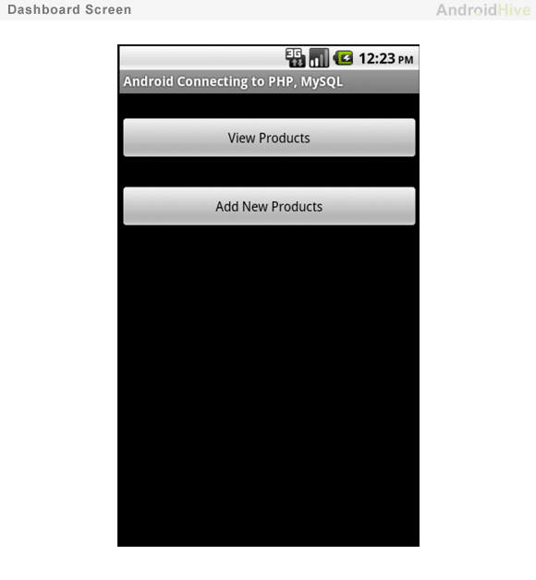

**4**. Open you main activity class which is **MainScreenActivity.java** and write click events for two button which are mentioned in **main_screen.xml** layout.

|  |
| --- |
| MainScreenActivity.java |
| package com.example.androidhive;    import android.app.Activity;  import android.content.Intent;  import android.os.Bundle;  import android.view.View;  import android.widget.Button;    public class MainScreenActivity extends Activity{        Button btnViewProducts;      Button btnNewProduct;        @Override      public void onCreate(Bundle savedInstanceState) {          super.onCreate(savedInstanceState);          setContentView(R.layout.main_screen);            // Buttons          btnViewProducts = (Button) findViewById(R.id.btnViewProducts);          btnNewProduct = (Button) findViewById(R.id.btnCreateProduct);            // view products click event          btnViewProducts.setOnClickListener(new View.OnClickListener() {                @Override              public void onClick(View view) {                  // Launching All products Activity                  Intent i = new Intent(getApplicationContext(), AllProductsActivity.class);                  startActivity(i);                }          });            // view products click event          btnNewProduct.setOnClickListener(new View.OnClickListener() {                @Override              public void onClick(View view) {                  // Launching create new product activity                  Intent i = new Intent(getApplicationContext(), NewProductActivity.class);                  startActivity(i);                }          });      }  } |

**Displaying All Products in ListView (Read)**

**5**. Now we need an Activity display all the products in list view format. As we know list view needs two xml files, one for listview and other is for single list row. Create two xml files under **res ⇒ layout** folder and name it as **all_products.xml** and **list_item.xml**

**all_products.xml**

|  |
| --- |
| all_products.xml |
| <?xml version="1.0" encoding="utf-8"?>  <LinearLayout xmlns:android="<http://schemas.android.com/apk/res/android>"      android:layout_width="fill_parent"      android:layout_height="fill_parent"      android:orientation="vertical">      <!-- Main ListView           Always give id value as list(@android:id/list)      -->      <ListView          android:id="@android:id/list"          android:layout_width="fill_parent"          android:layout_height="wrap_content"/>    </LinearLayout> |

**list_item.xml**

|  |
| --- |
| list_item.xml |
| <?xml version="1.0" encoding="utf-8"?>  <LinearLayout xmlns:android="<http://schemas.android.com/apk/res/android>"      android:layout_width="fill_parent"      android:layout_height="wrap_content"      android:orientation="vertical" >        <!-- Product id (pid) - will be HIDDEN - used to pass to other activity -->      <TextView          android:id="@+id/pid"          android:layout_width="fill_parent"          android:layout_height="wrap_content"          android:visibility="gone" />        <!-- Name Label -->      <TextView          android:id="@+id/name"          android:layout_width="fill_parent"          android:layout_height="wrap_content"          android:paddingTop="6dip"          android:paddingLeft="6dip"          android:textSize="17dip"          android:textStyle="bold" />    </LinearLayout> |

**6**. Create a new class file and name it as **AllProductsActivity.java**. In the following code

-> First a request is send to **get_all_products.php** file using a Background Async task thread.  
-> After getting JSON from get_all_products.php, i parsed it and displayed in a listview.  
-> If there are no products found **AddNewProductAcivity** is launched.

|  |
| --- |
| AllProductsActivity.java |
| package com.example.androidhive;    import java.util.ArrayList;  import java.util.HashMap;  import java.util.List;    import org.apache.http.NameValuePair;  import org.json.JSONArray;  import org.json.JSONException;  import org.json.JSONObject;    import android.app.ListActivity;  import android.app.ProgressDialog;  import android.content.Intent;  import android.os.AsyncTask;  import android.os.Bundle;  import android.util.Log;  import android.view.View;  import android.widget.AdapterView;  import android.widget.AdapterView.OnItemClickListener;  import android.widget.ListAdapter;  import android.widget.ListView;  import android.widget.SimpleAdapter;  import android.widget.TextView;    public class AllProductsActivity extends ListActivity {        // Progress Dialog      private ProgressDialog pDialog;        // Creating JSON Parser object      JSONParser jParser = new JSONParser();        ArrayList<HashMap<String, String>> productsList;        // url to get all products list      private static String url_all_products = "<http://api.androidhive.info/android_connect/get_all_products.php>";        // JSON Node names      private static final String TAG_SUCCESS = "success";      private static final String TAG_PRODUCTS = "products";      private static final String TAG_PID = "pid";      private static final String TAG_NAME = "name";        // products JSONArray      JSONArray products = null;        @Override      public void onCreate(Bundle savedInstanceState) {          super.onCreate(savedInstanceState);          setContentView(R.layout.all_products);            // Hashmap for ListView          productsList = new ArrayList<HashMap<String, String>>();            // Loading products in Background Thread          new LoadAllProducts().execute();            // Get listview          ListView lv = getListView();            // on seleting single product          // launching Edit Product Screen          lv.setOnItemClickListener(new OnItemClickListener() {                @Override              public void onItemClick(AdapterView<?> parent, View view,                      int position, long id) {                  // getting values from selected ListItem                  String pid = ((TextView) view.findViewById(R.id.pid)).getText()                          .toString();                    // Starting new intent                  Intent in = new Intent(getApplicationContext(),                          EditProductActivity.class);                  // sending pid to next activity                  in.putExtra(TAG_PID, pid);                    // starting new activity and expecting some response back                  startActivityForResult(in, 100);              }          });        }        // Response from Edit Product Activity      @Override      protected void onActivityResult(int requestCode, int resultCode, Intent data) {          super.onActivityResult(requestCode, resultCode, data);          // if result code 100          if (resultCode == 100) {              // if result code 100 is received              // means user edited/deleted product              // reload this screen again              Intent intent = getIntent();              finish();              startActivity(intent);          }        }        /**       * Background Async Task to Load all product by making HTTP Request       * */      class LoadAllProducts extends AsyncTask<String, String, String> {            /**           * Before starting background thread Show Progress Dialog           * */          @Override          protected void onPreExecute() {              super.onPreExecute();              pDialog = new ProgressDialog(AllProductsActivity.this);              pDialog.setMessage("Loading products. Please wait...");              pDialog.setIndeterminate(false);              pDialog.setCancelable(false);              pDialog.show();          }            /**           * getting All products from url           * */          protected String doInBackground(String... args) {              // Building Parameters              List<NameValuePair> params = new ArrayList<NameValuePair>();              // getting JSON string from URL              JSONObject json = jParser.makeHttpRequest(url_all_products, "GET", params);                // Check your log cat for JSON reponse              Log.d("All Products: ", json.toString());                try {                  // Checking for SUCCESS TAG                  int success = json.getInt(TAG_SUCCESS);                    if (success == 1) {                      // products found                      // Getting Array of Products                      products = json.getJSONArray(TAG_PRODUCTS);                        // looping through All Products                      for (int i = 0; i < products.length(); i++) {                          JSONObject c = products.getJSONObject(i);                            // Storing each json item in variable                          String id = c.getString(TAG_PID);                          String name = c.getString(TAG_NAME);                            // creating new HashMap                          HashMap<String, String> map = new HashMap<String, String>();                            // adding each child node to HashMap key => value                          map.put(TAG_PID, id);                          map.put(TAG_NAME, name);                            // adding HashList to ArrayList                          productsList.add(map);                      }                  } else {                      // no products found                      // Launch Add New product Activity                      Intent i = new Intent(getApplicationContext(),                              NewProductActivity.class);                      // Closing all previous activities                      i.addFlags(Intent.FLAG_ACTIVITY_CLEAR_TOP);                      startActivity(i);                  }              } catch (JSONException e) {                  e.printStackTrace();              }                return null;          }            /**           * After completing background task Dismiss the progress dialog           * **/          protected void onPostExecute(String file_url) {              // dismiss the dialog after getting all products              pDialog.dismiss();              // updating UI from Background Thread              runOnUiThread(new Runnable() {                  public void run() {                      /**                       * Updating parsed JSON data into ListView                       * */                      ListAdapter adapter = new SimpleAdapter(                              AllProductsActivity.this, productsList,                              R.layout.list_item, new String[] { TAG_PID,                                      TAG_NAME},                              new int[] { R.id.pid, R.id.name });                      // updating listview                      setListAdapter(adapter);                  }              });            }        }  } |

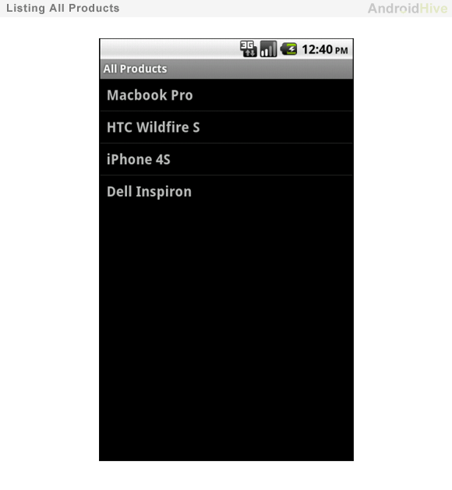

**Adding a New Product (Write)**

**7**. Create a new view and acivity to add a new product into mysql database. Create a simple form which contains EditText for product name, price and description.

Create a new xml file and name it as **add_product.xml** and paste the following code to create a simple form.

**add_product.xml**

|  |
| --- |
| add_product.xml |
| <?xml version="1.0" encoding="utf-8"?>  <LinearLayout xmlns:android="<http://schemas.android.com/apk/res/android>"      android:layout_width="match_parent"      android:layout_height="match_parent"      android:orientation="vertical" >        <!-- Name Label -->      <TextView android:layout_width="fill_parent"          android:layout_height="wrap_content"          android:text="Product Name"          android:paddingLeft="10dip"          android:paddingRight="10dip"          android:paddingTop="10dip"          android:textSize="17dip"/>        <!-- Input Name -->      <EditText android:id="@+id/inputName"          android:layout_width="fill_parent"          android:layout_height="wrap_content"          android:layout_margin="5dip"          android:layout_marginBottom="15dip"          android:singleLine="true"/>        <!-- Price Label -->      <TextView android:layout_width="fill_parent"          android:layout_height="wrap_content"          android:text="Price"          android:paddingLeft="10dip"          android:paddingRight="10dip"          android:paddingTop="10dip"          android:textSize="17dip"/>        <!-- Input Price -->      <EditText android:id="@+id/inputPrice"          android:layout_width="fill_parent"          android:layout_height="wrap_content"          android:layout_margin="5dip"          android:layout_marginBottom="15dip"          android:singleLine="true"          android:inputType="numberDecimal"/>        <!-- Description Label -->      <TextView android:layout_width="fill_parent"          android:layout_height="wrap_content"          android:text="Description"          android:paddingLeft="10dip"          android:paddingRight="10dip"          android:paddingTop="10dip"          android:textSize="17dip"/>        <!-- Input description -->      <EditText android:id="@+id/inputDesc"          android:layout_width="fill_parent"          android:layout_height="wrap_content"          android:layout_margin="5dip"          android:layout_marginBottom="15dip"          android:lines="4"          android:gravity="top"/>        <!-- Button Create Product -->      <Button android:id="@+id/btnCreateProduct"          android:layout_width="fill_parent"          android:layout_height="wrap_content"          android:text="Create Product"/>    </LinearLayout> |

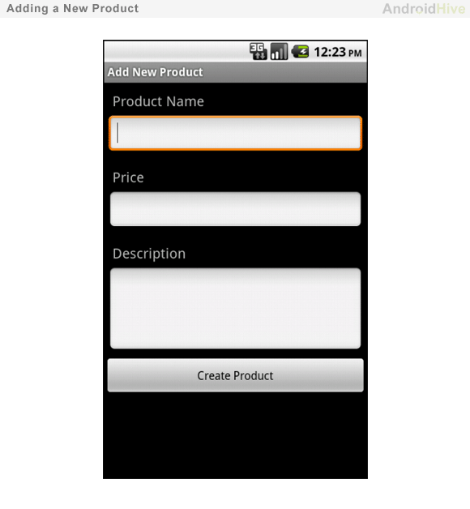

**8**. Now create new Activity to insert a new product into mysql database. Create a class file and name it as **NewProductActivity.java** and type the following code. In the following code

-> First new product data is read from the EditText form and formatted into a basic params.  
-> A request is made to **create_product.php** to create a new product through HTTP post.  
-> After getting json response from create_product.php, If success bit is 1 then list view is refreshed with newly added product.

|  |
| --- |
| NewProductActivity.java |
| package com.example.androidhive;    import java.util.ArrayList;  import java.util.List;    import org.apache.http.NameValuePair;  import org.apache.http.message.BasicNameValuePair;  import org.json.JSONException;  import org.json.JSONObject;    import android.app.Activity;  import android.app.ProgressDialog;  import android.content.Intent;  import android.os.AsyncTask;  import android.os.Bundle;  import android.util.Log;  import android.view.View;  import android.widget.Button;  import android.widget.EditText;    public class NewProductActivity extends Activity {        // Progress Dialog      private ProgressDialog pDialog;        JSONParser jsonParser = new JSONParser();      EditText inputName;      EditText inputPrice;      EditText inputDesc;        // url to create new product      private static String url_create_product = "<http://api.androidhive.info/android_connect/create_product.php>";        // JSON Node names      private static final String TAG_SUCCESS = "success";        @Override      public void onCreate(Bundle savedInstanceState) {          super.onCreate(savedInstanceState);          setContentView(R.layout.add_product);            // Edit Text          inputName = (EditText) findViewById(R.id.inputName);          inputPrice = (EditText) findViewById(R.id.inputPrice);          inputDesc = (EditText) findViewById(R.id.inputDesc);            // Create button          Button btnCreateProduct = (Button) findViewById(R.id.btnCreateProduct);            // button click event          btnCreateProduct.setOnClickListener(new View.OnClickListener() {                @Override              public void onClick(View view) {                  // creating new product in background thread                  new CreateNewProduct().execute();              }          });      }        /**       * Background Async Task to Create new product       * */      class CreateNewProduct extends AsyncTask<String, String, String> {            /**           * Before starting background thread Show Progress Dialog           * */          @Override          protected void onPreExecute() {              super.onPreExecute();              pDialog = new ProgressDialog(NewProductActivity.this);              pDialog.setMessage("Creating Product..");              pDialog.setIndeterminate(false);              pDialog.setCancelable(true);              pDialog.show();          }            /**           * Creating product           * */          protected String doInBackground(String... args) {              String name = inputName.getText().toString();              String price = inputPrice.getText().toString();              String description = inputDesc.getText().toString();                // Building Parameters              List<NameValuePair> params = new ArrayList<NameValuePair>();              params.add(new BasicNameValuePair("name", name));              params.add(new BasicNameValuePair("price", price));              params.add(new BasicNameValuePair("description", description));                // getting JSON Object              // Note that create product url accepts POST method              JSONObject json = jsonParser.makeHttpRequest(url_create_product,                      "POST", params);                // check log cat fro response              Log.d("Create Response", json.toString());                // check for success tag              try {                  int success = json.getInt(TAG_SUCCESS);                    if (success == 1) {                      // successfully created product                      Intent i = new Intent(getApplicationContext(), AllProductsActivity.class);                      startActivity(i);                        // closing this screen                      finish();                  } else {                      // failed to create product                  }              } catch (JSONException e) {                  e.printStackTrace();              }                return null;          }            /**           * After completing background task Dismiss the progress dialog           * **/          protected void onPostExecute(String file_url) {              // dismiss the dialog once done              pDialog.dismiss();          }        }  } |

**Reading, Updating and Deleting a Single Product**

**9**. If you notice the AllProductsActivity.java, In listview i am launching EditProductAcivity.java once a single list item is selected. So create xml file called **edit_product.xml** and create a form which is same as create_product.xml.

**edit_product.xml**

|  |
| --- |
| edit_product.xml |
| <?xml version="1.0" encoding="utf-8"?>  <LinearLayout xmlns:android="<http://schemas.android.com/apk/res/android>"      android:layout_width="match_parent"      android:layout_height="match_parent"      android:orientation="vertical" >        <!-- Name Label -->      <TextView android:layout_width="fill_parent"          android:layout_height="wrap_content"          android:text="Product Name"          android:paddingLeft="10dip"          android:paddingRight="10dip"          android:paddingTop="10dip"          android:textSize="17dip"/>        <!-- Input Name -->      <EditText android:id="@+id/inputName"          android:layout_width="fill_parent"          android:layout_height="wrap_content"          android:layout_margin="5dip"          android:layout_marginBottom="15dip"          android:singleLine="true"/>        <!-- Price Label -->      <TextView android:layout_width="fill_parent"          android:layout_height="wrap_content"          android:text="Price"          android:paddingLeft="10dip"          android:paddingRight="10dip"          android:paddingTop="10dip"          android:textSize="17dip"/>        <!-- Input Price -->      <EditText android:id="@+id/inputPrice"          android:layout_width="fill_parent"          android:layout_height="wrap_content"          android:layout_margin="5dip"          android:layout_marginBottom="15dip"          android:singleLine="true"          android:inputType="numberDecimal"/>        <!-- Description Label -->      <TextView android:layout_width="fill_parent"          android:layout_height="wrap_content"          android:text="Description"          android:paddingLeft="10dip"          android:paddingRight="10dip"          android:paddingTop="10dip"          android:textSize="17dip"/>        <!-- Input description -->      <EditText android:id="@+id/inputDesc"          android:layout_width="fill_parent"          android:layout_height="wrap_content"          android:layout_margin="5dip"          android:layout_marginBottom="15dip"          android:lines="4"          android:gravity="top"/>        <LinearLayout android:layout_width="fill_parent"          android:layout_height="wrap_content"          android:orientation="horizontal">          <!-- Button Create Product -->      <Button android:id="@+id/btnSave"          android:layout_width="fill_parent"          android:layout_height="wrap_content"          android:text="Save Changes"          android:layout_weight="1"/>        <!-- Button Create Product -->      <Button android:id="@+id/btnDelete"          android:layout_width="fill_parent"          android:layout_height="wrap_content"          android:text="Delete"          android:layout_weight="1"/>      </LinearLayout>    </LinearLayout> |

**10**. Create a class file for edit_product.xml and name it as **EditProductActivity.java** and fill it with following code. In the following code

-> First product id (**pid**) is read from the intent which is sent from listview.  
-> A request is made to **get_product_details.php** and after getting product details in json format, I parsed the json and displayed in EditText.  
-> After displaying product data in the form if user clicks on Save Changes Button, another HTTP request is made to **update_product.php** to store updated product data.  
-> If the user selected Delete Product Button, HTTP request is made to **delete_product.php** and product is deleted from mysql database, and listview is refreshed with new product list.

|  |
| --- |
| EditProductActivity.java |
| package com.example.androidhive;    import java.util.ArrayList;  import java.util.List;    import org.apache.http.NameValuePair;  import org.apache.http.message.BasicNameValuePair;  import org.json.JSONArray;  import org.json.JSONException;  import org.json.JSONObject;    import android.app.Activity;  import android.app.ProgressDialog;  import android.content.Intent;  import android.os.AsyncTask;  import android.os.Bundle;  import android.util.Log;  import android.view.View;  import android.widget.Button;  import android.widget.EditText;    public class EditProductActivity extends Activity {        EditText txtName;      EditText txtPrice;      EditText txtDesc;      EditText txtCreatedAt;      Button btnSave;      Button btnDelete;        String pid;        // Progress Dialog      private ProgressDialog pDialog;        // JSON parser class      JSONParser jsonParser = new JSONParser();        // single product url      private static final String url_product_detials = "<http://api.androidhive.info/android_connect/get_product_details.php>";        // url to update product      private static final String url_update_product = "<http://api.androidhive.info/android_connect/update_product.php>";        // url to delete product      private static final String url_delete_product = "<http://api.androidhive.info/android_connect/delete_product.php>";        // JSON Node names      private static final String TAG_SUCCESS = "success";      private static final String TAG_PRODUCT = "product";      private static final String TAG_PID = "pid";      private static final String TAG_NAME = "name";      private static final String TAG_PRICE = "price";      private static final String TAG_DESCRIPTION = "description";        @Override      public void onCreate(Bundle savedInstanceState) {          super.onCreate(savedInstanceState);          setContentView(R.layout.edit_product);            // save button          btnSave = (Button) findViewById(R.id.btnSave);          btnDelete = (Button) findViewById(R.id.btnDelete);            // getting product details from intent          Intent i = getIntent();            // getting product id (pid) from intent          pid = i.getStringExtra(TAG_PID);            // Getting complete product details in background thread          new GetProductDetails().execute();            // save button click event          btnSave.setOnClickListener(new View.OnClickListener() {                @Override              public void onClick(View arg0) {                  // starting background task to update product                  new SaveProductDetails().execute();              }          });            // Delete button click event          btnDelete.setOnClickListener(new View.OnClickListener() {                @Override              public void onClick(View arg0) {                  // deleting product in background thread                  new DeleteProduct().execute();              }          });        }        /**       * Background Async Task to Get complete product details       * */      class GetProductDetails extends AsyncTask<String, String, String> {            /**           * Before starting background thread Show Progress Dialog           * */          @Override          protected void onPreExecute() {              super.onPreExecute();              pDialog = new ProgressDialog(EditProductActivity.this);              pDialog.setMessage("Loading product details. Please wait...");              pDialog.setIndeterminate(false);              pDialog.setCancelable(true);              pDialog.show();          }            /**           * Getting product details in background thread           * */          protected String doInBackground(String... params) {                // updating UI from Background Thread              runOnUiThread(new Runnable() {                  public void run() {                      // Check for success tag                      int success;                      try {                          // Building Parameters                          List<NameValuePair> params = new ArrayList<NameValuePair>();                          params.add(new BasicNameValuePair("pid", pid));                            // getting product details by making HTTP request                          // Note that product details url will use GET request                          JSONObject json = jsonParser.makeHttpRequest(                                  url_product_detials, "GET", params);                            // check your log for json response                          Log.d("Single Product Details", json.toString());                            // json success tag                          success = json.getInt(TAG_SUCCESS);                          if (success == 1) {                              // successfully received product details                              JSONArray productObj = json                                      .getJSONArray(TAG_PRODUCT); // JSON Array                                // get first product object from JSON Array                              JSONObject product = productObj.getJSONObject(0);                                // product with this pid found                              // Edit Text                              txtName = (EditText) findViewById(R.id.inputName);                              txtPrice = (EditText) findViewById(R.id.inputPrice);                              txtDesc = (EditText) findViewById(R.id.inputDesc);                                // display product data in EditText                              txtName.setText(product.getString(TAG_NAME));                              txtPrice.setText(product.getString(TAG_PRICE));                              txtDesc.setText(product.getString(TAG_DESCRIPTION));                            }else{                              // product with pid not found                          }                      } catch (JSONException e) {                          e.printStackTrace();                      }                  }              });                return null;          }            /**           * After completing background task Dismiss the progress dialog           * **/          protected void onPostExecute(String file_url) {              // dismiss the dialog once got all details              pDialog.dismiss();          }      }        /**       * Background Async Task to  Save product Details       * */      class SaveProductDetails extends AsyncTask<String, String, String> {            /**           * Before starting background thread Show Progress Dialog           * */          @Override          protected void onPreExecute() {              super.onPreExecute();              pDialog = new ProgressDialog(EditProductActivity.this);              pDialog.setMessage("Saving product ...");              pDialog.setIndeterminate(false);              pDialog.setCancelable(true);              pDialog.show();          }            /**           * Saving product           * */          protected String doInBackground(String... args) {                // getting updated data from EditTexts              String name = txtName.getText().toString();              String price = txtPrice.getText().toString();              String description = txtDesc.getText().toString();                // Building Parameters              List<NameValuePair> params = new ArrayList<NameValuePair>();              params.add(new BasicNameValuePair(TAG_PID, pid));              params.add(new BasicNameValuePair(TAG_NAME, name));              params.add(new BasicNameValuePair(TAG_PRICE, price));              params.add(new BasicNameValuePair(TAG_DESCRIPTION, description));                // sending modified data through http request              // Notice that update product url accepts POST method              JSONObject json = jsonParser.makeHttpRequest(url_update_product,                      "POST", params);                // check json success tag              try {                  int success = json.getInt(TAG_SUCCESS);                    if (success == 1) {                      // successfully updated                      Intent i = getIntent();                      // send result code 100 to notify about product update                      setResult(100, i);                      finish();                  } else {                      // failed to update product                  }              } catch (JSONException e) {                  e.printStackTrace();              }                return null;          }            /**           * After completing background task Dismiss the progress dialog           * **/          protected void onPostExecute(String file_url) {              // dismiss the dialog once product uupdated              pDialog.dismiss();          }      }        /*****************************************************************       * Background Async Task to Delete Product       * */      class DeleteProduct extends AsyncTask<String, String, String> {            /**           * Before starting background thread Show Progress Dialog           * */          @Override          protected void onPreExecute() {              super.onPreExecute();              pDialog = new ProgressDialog(EditProductActivity.this);              pDialog.setMessage("Deleting Product...");              pDialog.setIndeterminate(false);              pDialog.setCancelable(true);              pDialog.show();          }            /**           * Deleting product           * */          protected String doInBackground(String... args) {                // Check for success tag              int success;              try {                  // Building Parameters                  List<NameValuePair> params = new ArrayList<NameValuePair>();                  params.add(new BasicNameValuePair("pid", pid));                    // getting product details by making HTTP request                  JSONObject json = jsonParser.makeHttpRequest(                          url_delete_product, "POST", params);                    // check your log for json response                  Log.d("Delete Product", json.toString());                    // json success tag                  success = json.getInt(TAG_SUCCESS);                  if (success == 1) {                      // product successfully deleted                      // notify previous activity by sending code 100                      Intent i = getIntent();                      // send result code 100 to notify about product deletion                      setResult(100, i);                      finish();                  }              } catch (JSONException e) {                  e.printStackTrace();              }                return null;          }            /**           * After completing background task Dismiss the progress dialog           * **/          protected void onPostExecute(String file_url) {              // dismiss the dialog once product deleted              pDialog.dismiss();            }        }  } |

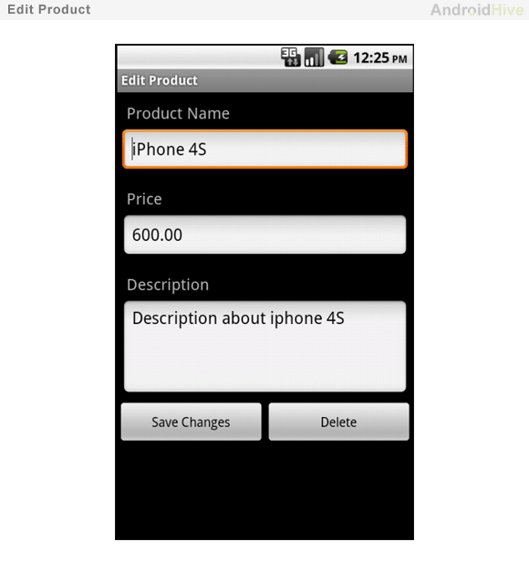

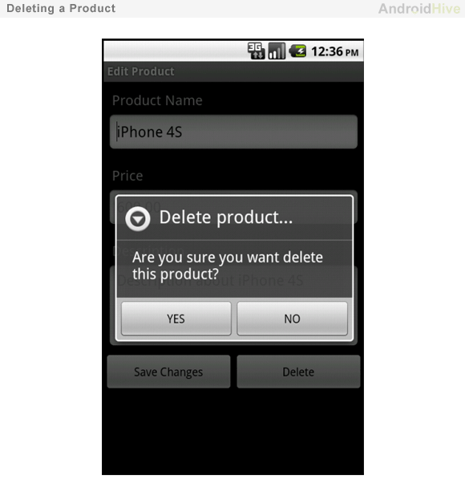

**JSON Parser Class**

I used a JSON Parser class to get JSON from URL. This class supports two http request methods GET and POST to get json from url.

|  |
| --- |
| JSONParser.java |
| package com.example.androidhive;    import java.io.BufferedReader;  import java.io.IOException;  import java.io.InputStream;  import java.io.InputStreamReader;  import java.io.UnsupportedEncodingException;  import java.util.List;    import org.apache.http.HttpEntity;  import org.apache.http.HttpResponse;  import org.apache.http.NameValuePair;  import org.apache.http.client.ClientProtocolException;  import org.apache.http.client.entity.UrlEncodedFormEntity;  import org.apache.http.client.methods.HttpGet;  import org.apache.http.client.methods.HttpPost;  import org.apache.http.client.utils.URLEncodedUtils;  import org.apache.http.impl.client.DefaultHttpClient;  import org.json.JSONException;  import org.json.JSONObject;    import android.util.Log;    public class JSONParser {        static InputStream is = null;      static JSONObject jObj = null;      static String json = "";        // constructor      public JSONParser() {        }        // function get json from url      // by making HTTP POST or GET mehtod      public JSONObject makeHttpRequest(String url, String method,              List<NameValuePair> params) {            // Making HTTP request          try {                // check for request method              if(method == "POST"){                  // request method is POST                  // defaultHttpClient                  DefaultHttpClient httpClient = new DefaultHttpClient();                  HttpPost httpPost = new HttpPost(url);                  httpPost.setEntity(new UrlEncodedFormEntity(params));                    HttpResponse httpResponse = httpClient.execute(httpPost);                  HttpEntity httpEntity = httpResponse.getEntity();                  is = httpEntity.getContent();                }else if(method == "GET"){                  // request method is GET                  DefaultHttpClient httpClient = new DefaultHttpClient();                  String paramString = URLEncodedUtils.format(params, "utf-8");                  url += "?" + paramString;                  HttpGet httpGet = new HttpGet(url);                    HttpResponse httpResponse = httpClient.execute(httpGet);                  HttpEntity httpEntity = httpResponse.getEntity();                  is = httpEntity.getContent();              }            } catch (UnsupportedEncodingException e) {              e.printStackTrace();          } catch (ClientProtocolException e) {              e.printStackTrace();          } catch (IOException e) {              e.printStackTrace();          }            try {              BufferedReader reader = new BufferedReader(new InputStreamReader(                      is, "iso-8859-1"), 8);              StringBuilder sb = new StringBuilder();              String line = null;              while ((line = reader.readLine()) != null) {                  sb.append(line + "\n");              }              is.close();              json = sb.toString();          } catch (Exception e) {              Log.e("Buffer Error", "Error converting result " + e.toString());          }            // try parse the string to a JSON object          try {              jObj = new JSONObject(json);          } catch (JSONException e) {              Log.e("JSON Parser", "Error parsing data " + e.toString());          }            // return JSON String          return jObj;        }  } |

Run your project and test the application. You might get lot of errors. Always use **Log Cat** to debug your application, and if you couldn’t solve your errors please do comment here.